Available online at [www.sciencedirect.com](http://www.sciencedirect.com/)



AASRI Procedia 3 (2012) 528 – 533

2012 AASRI Conference on Modeling, Identification and Control

Use of Non-linear Properties of Stimuli-sensitive Polymers in Image Display Systems

I.Suleimenov*a\**, N.Semenyakin*a,b*, G.Munc, D.Shaltykova*a*, S.Panchenko*a,c*,

Z.Sedlakovad

*aAlmaty University of Power Engineering and Telecommunications, 126 Baitursynova, Almaty 050013, Kazakhstan*

*bKazakh-British Technical University, 59 Toli bi, Almaty 050000, Kazakhstan*

*cKazakh National University, 71 Al-Farabi, Almaty 050038, Kazakhstan*

*dDepartment of Controlled Polymer Synthesis,Institute of Macromolecular Chemistry AS CR, 2 Heyrovskeho sq., Prague 16206, Czech Republic*

**Abstract**

It is demonstrated that using non-linear properties of stimuli-sensitive polymers enables dramatic simplification of design of image display systems. Proposed scheme is based on joint action of two heating elements placed in each pixel. Preliminary experimental results showing feasibility of proposed approach are described in this report.

© 2012 The Authors. Published by Elsevier B.V. Open access under [CC BY-NC-ND license.](http://creativecommons.org/licenses/by-nc-nd/3.0/)

© 2012 Published by Elsevier B.V. Selection and/or peer review [under responsi](http://creativecommons.org/licenses/by-nc-nd/3.0/)bility of American Applied Science Research Institute

Selection and/or peer review under responsibility of American Applied Science Research Institute

*Keywords*: display systems, stimuli-sensitive polymers, phase transition

# Introduction

Several schemes of image display have been implemented as of today. Liquid crystal and plasma displays, which create images using a combination of pixels – elements that are capable of independently changing their optical characteristics, are widespread Ergozhin et al., 2008.

* Corresponding author. Tel.: +7-705-295-29-19;

*E-mail address:* [esenych@yandex.ru](mailto:esenych@yandex.ru)

2212-6716 © 2012 The Authors. Published by Elsevier B.V. Open access under [CC BY-NC-ND license.](http://creativecommons.org/licenses/by-nc-nd/3.0/) Selection and/or peer review under responsibility of American Applied Science Research Institute doi:10.1016/j.aasri.2012.11.083

A common disadvantage of existing schemes is a bulky system of operation, which requires a large number of electronic switches, the details are provided in Ergozhin et al., 2008. This is due to the fact that, from a radiotechnical point of view, each display element (pixel) represents a two-pole, which is a device with contacts that are used to receive the operating signal. With regard to plasma displays gas discharge cells constitute such two-poles, while a cell filled with a substance that maintains rotation of plane of polarization under the impact of electric pole.

The maximum number of electronic switches that can be connected to a two-pole is, obviously, two. Consequently, the minimum quantity of image-producing operating switches is implemented using the matrix scheme that is currently in use in abovementioned displays. In such scheme each row and each column is operated through an individual electronic switch. Therefore, the minimum number of switches is equal to the sum of number of rows and columns. For the minimum standard of 800x600 pixels it is equal to 1400 switches; for a more prevailing standard of 1024x768 pixels it is equal to 1792 switches.

The number of operating elements actually in use is, however, significantly greater than this value, because the actual switching of matrix, whose equivalent scheme may be presented as a combination of resistors, creates current leakage. To prevent this, modern LCD-panel schemes utilize transistor panels.

Noted disadvantages of image display systems based on elements with linear control lead to increase in cost of production of displays, also impose some constraints on their resolution.

This paper demonstrates that mentioned disadvantages can be eliminated as a result of utilizing non-linear qualities of stimuli-sensitive, particularly thermo-sensitive polymers. Substances of this kind have been subject of extended research Dergunov et al., Okano, Barker et al. and Tanaka; large number of polymers, whose solutions sustain phase transition as a result of change in temperature, have been synthesized. Previous research Dergunov et al., Okano, Barker et al. and Tanaka indicates that there is a strong relation of the parameters of a solution to stimuli in the area of phase transition, as summarized in Ergozhin et al.

Test experiments conducted in this paper show that this fact may be used as a foundation of new image display systems.

* 1. *Image display using stimuli-sensitive polymers*

As noted in Ergozhin et al., light-scattering medium (fig.1) with controlled change in optical density can be used in producing images. In this scheme the screen is divided into combinations of pixels, with each one controlled by an independent signals. The screen is filled with the polymer, sustaining phase transition under impact of one or another stimulus. As a result of optical emission affecting lateral side of the screen, pixels that sustained phase transition start scattering the light. Visually they are regarded as illuminated. Pixels that did not sustain phase transition remain transparent and let through the light; under lateral illumination they are perceived as dark.

Significantly, phase transition may be implemented by signals of various origins; the signals do not need to be of electric nature. For instance, a range of problems (such as synthesis of stationary images) can be solved using temperature-based control.

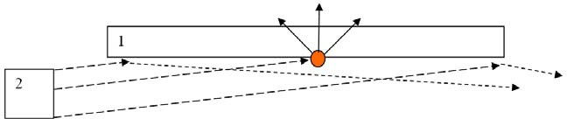

Fig. 1 Positions of the light emitter (2) relative to the panel in image display scheme based on light-scattering media

In the simplest example a resistor providing calefaction of solution by emitting Joule heat may be used to implement phase transition in an individual pixel. In principle, such scheme is functional; however it is not free of disadvantages common to plasma and LCD displays, mentioned above. The minimum quantity of electronic switches (1) in such scheme is equal to the sum of number of rows and columns as well (Fig.2).

Besides, in order to prevent current leakage and maintain reliable switching such scheme has to be complemented with resistors along with additional diodes (3) and shunting heating resistors (fig.2).

We will demonstrate that these shortcomings may be overcome by using a scheme with two heating resistors in a separate cell (pixel). Figure 3 shows the optical density (turbidity) of stimuli-sensitive polymer solution as a function of temperature.

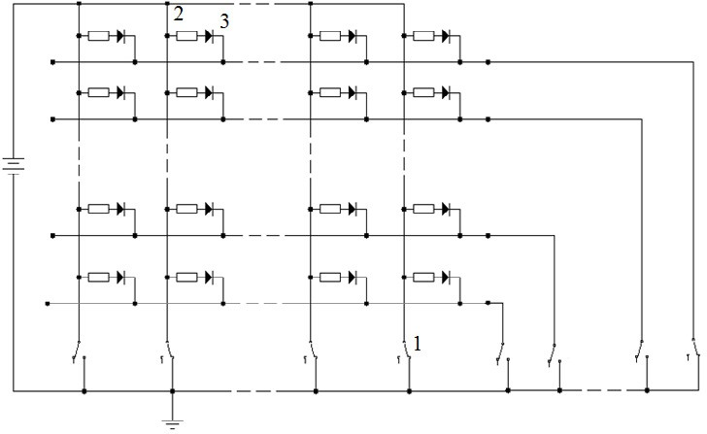

Fig. 2 Schematic implementation of screen control resistive (?) matrix; 1 – operating switches, resistors (2) are heating elements, diodes

(3) block current leakage.

Relations of this kind are characteristic to a broad range of polymers, possessing both hydrophobic and hydrophilic qualities (a typical example of this is poly-N-isopropylacrylamide, used in this paper to conduct test experiments).

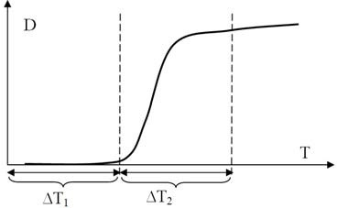

Fig. 3 – Using non-linear relation of thermo-sensitive polymer solution’s optical density to temperature in tensor imaging scheme

Figure 3 highlights that one can select parameters so that heating of the solution by one resistor (increase of temperature by T1) will not lead to a phase transition, while heating by two resistors (increase of temperature by T1+T2) which doubles the intensity of heat will lead to an abrupt increase in optical density.

Certainly, this scenario is only determined by a non-linear type of relationship between optical density and temperature and is not possible within a linear system.

From a radiotechnical perspective an image element (pixel) containing two non-connected resistors is a four-pole. Four switches instead of two may be attached to this element, significantly reducing the total number of electronic switches in the screen operation scheme.

A simplified operation scheme demonstrating the possibility of a dramatic decrease in number of switches is shown on fig.4. Columns and rows in this scheme are divided into groups, while one switch commutates a

*N*

group of rows or columns at once. To be more precise, *N* columns are divided into groups. For *N* = 9

(as in fig. 4) number of groups is three. Switches from the set (1, fig.4) commutate, i.e. connect the whole group to power supply at once. Columns # 1, 2 and 3 are singled out in each group. Columns #1 of each group are combined in yet another group that is commutated by the first switch from the set (2, fig.4). In a similar manner, groups commutated by other switches from the set 2 consist of columns #2 and #3 of groups united by switches from set 1.

Obviously, current will flow through a certain column only provided that corresponding switches from both groups are set to “on” position.

Commutation of rows is carried out in the same manner (fig. 4).

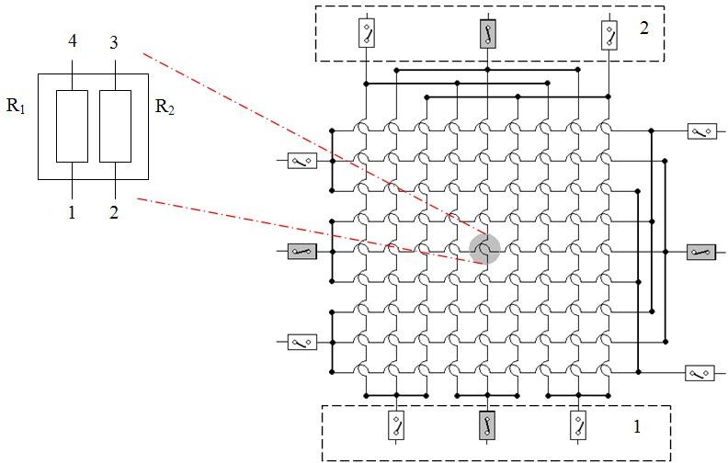

Fig. 4 Tensor scheme of image formation and zoomed-in scheme of a cell responsible for an individual pixel; initiation of gray-shaded switches ensures phase transition in an individual pixel, shunting diodes are not shown.

From a mathematical point of view pixels of this screen can be considered as elements of a four- dimensional cube, located on the plane in a certain order. Commutation is performed along the coordinate lines of such 4-dimensional cube, justifying the use of term “tensor scheme”.

In the example illustrated in fig. 4 the number of “rows” in each dimension of this 4-dimensional cube is equal to 3, what corresponds to 34=92=81 pixels.

*N*

In general case 4 can be used to operate the tensor scheme providing image display by *N * *N*

pixels. While there is no significant benefit from that on smaller displays, even the case of 1024 by 768 pixels standard shows that total number of switches can be reduced from 1792 to 60.

The most significant part is that tensor scheme enables using fewer shunting diodes, because rows and columns in the operating scheme are almost entirely untied.

# Experimental

Test experiments were carried out in order to prove the feasibility of tensor scheme are described below. An experimental cuvette containing two adjacent cells with two heating resistors in each one was constructed (fig. 5).

Optically transparent cuvettes of 1 cub cm were used as cells. A pair of heating resistors with nominal resistance equal to 100 Ohms was placed at the bottom of the cuvette. The cuvettes were filled with 0.1 m/liter solution of poly-N-isopropylacrylamide.

The speed of phase transition was registered with the aid of optical scheme.

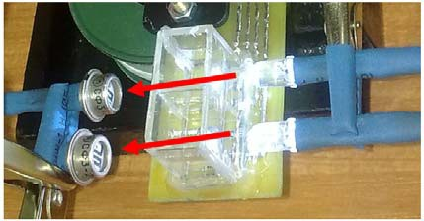

Fig. 5 Photo of the device used to test tensor connection of cells in the screen matrix.

LEDs were used as a source of visible optical emission. Receivers of emissions (light-dependent resistors) were located at the opposite side of the cuvette at 15 mm distance. A specially designed electronic scheme capable of recording measurable values of resistance of a light-dependent resistor in a text file at time resolution of 1-100 microseconds was employed.

Knowing the resistance of light-dependent resistor at the initial time point (transparent solution) one can determine relative change in optical density of the medium during phase transition sustained in the studied solution.

To prove the feasibility of tensor scheme following series of measurements were taken:

1. Phase transition speed kinetics (the heating was supplied by one resistor, applied voltage was varied).
2. Comparing phase transition kinetics in schemes with one and two heating resistors within the range of voltage applied in series 1; significantly, the cell in use allows to make a comparison of phase transition in two independent cells at once, and is accomplished by using two-channel photo registration

# Results and discussion

Figure 6 demonstrates the result of poly-N-isopropylacrylamide phase transition kinetics measurements, *c*

= 0,2 M, in the used cell under various voltages applied to heating elements. Relative transparency, denoted as D, was registered; for curve 1 the start temperature was at 280, the ending temperature was at 460.

As it was expected, an increase in speed of heating leads to a shorter phase transition time. The most significant result of these measurements is the opportunity to choose a heating regime for the tensor scheme.

Figure 7 demonstrates the results of a combined experiment under following conditions:  Each cell contains two 100 Ohm-resistors;

 The heating of one cell is provided by one resistor, another cell is heated by two;

 Voltage of power supply of each resistor was 12 V, i.e. first cell produces power of 1,44 Watts, second one – 2,88 Watts

Initial temperature of solution in both cells of the couvette was at 280, the temperature after the effect: in first cell - 390, in second cell - 470.

The functions of optical density D of the solutions in first and second cells under such regime of heating are shown in fig.7, curves 1 and 2 respectively.

One can see that under given parameters heating by one resistor does not lead to phase transition, whereas two resistors provide sufficient heating for the same period of time.

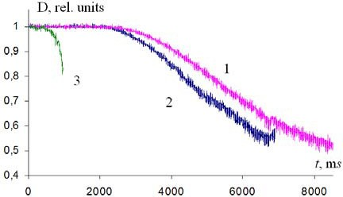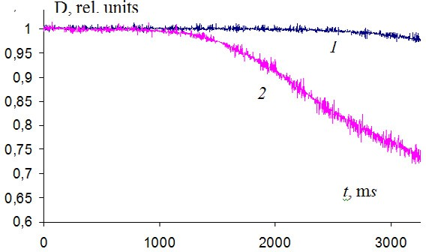

Fig. 6 poly-N-isopropylacrylamide phase transition kinetics under various voltages; U = 8,7 (1), 12(2)  24(3) V.

Fig. 7 – optical density as functions of time under different cell heating regimes: heating by one (1) and by two (2) 100 Ohm resistors.

# Conclusion

In conclusion, experiments of this research prove the feasibility of suggested tensor scheme of image display. It was found that there is a possibility to dramatic simplification of radioelectronic operation schemes of image display by means of employing nonlinear qualities of thermo-sensitive polymers, even if the chosen polymer medium did not show optimal properties for this scheme. Such schemes in their following versions may be used for applications that do not require frequent frame change (billboards and similar devices). Finding and optimization of properties of polymers and composites that show faster response of phase transition, including composites containing immersed nanoparticles, presents significant potential of the suggested scheme improvement.

# References

1. E.E.Ergozhin, A.B.Zezin, I.E.Suleimenov, G.A. Mun, Hydrophilic polymers in nanotechnology and nanoelectronics (in Russian), LEM, Almaty - Moscow, 2008.
2. S.. Dergunov, G.A. Mun, M.A.Dergunov, I.E.Suleimenov, E.Pinkhassik Tunable thermosensitivity in multistimuli-responsive terpolymer, React. Funct. Polym. 71 (2011) 1129-1136.
3. T. Okano Molecular design of temperature-responsive polymers as intelligent materials // Adv. Polym. Sci. 109 (1993) 179-197.
4. C.Barker, J. M. G.Cowie, T. N.Huckerby, D.A. Shaw, I.Soutar, Swanson L. Studies of the "Smart" Thermoresponsive Behavior of Copolymers of N-Isopropylacrylamide and N,N-Dimethylacrylamide in Dilute Aqueous Solution, Macromolecules 36 (2003) 7765-7770.
5. F. Tanaka, T. Koga, F.M. Winnik, Temperature-Responsive Polymers in Mixed Solvents: Competitive Hydrogen Bonds Cause Cononsolvency, PRL 101 (2008), 028302.